Excel On Air
About Me: https://github.com/sanjeevlcc

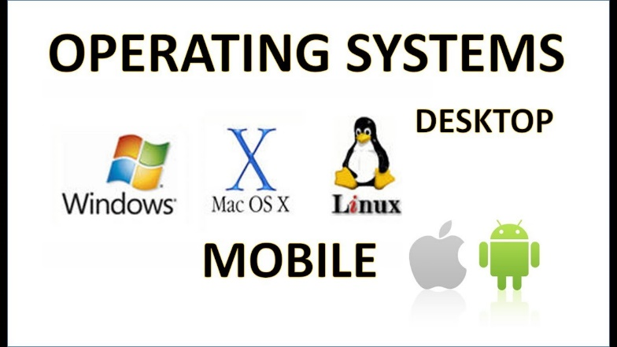
Operating Systems?
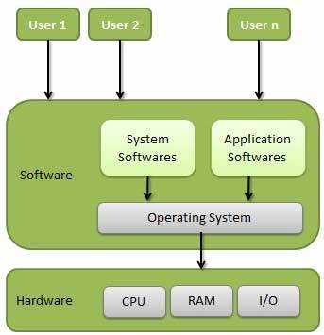
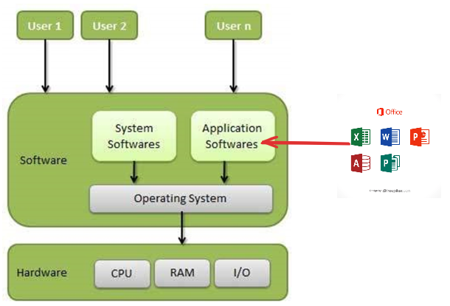

What Are Office Packages?
Office Packages (also called Office Suites) are collections of software applications designed to help users perform everyday tasks such as:
- Writing documents
- Creating spreadsheets
- Making presentations
- Managing emails
- Handling databases
- Collaboration and file sharing
They are used in businesses, schools, government offices, and personal work.

Examples of Common Tasks Done Using Office Packages
- Writing reports (Word processors)
- Preparing budgets (Spreadsheet tools)
- Making PowerPoint slides (Presentation tools)
- Storing records (Database tools)
- Email communication (Email clients)

1. Microsoft Office (MS Office) — Most popular office suite
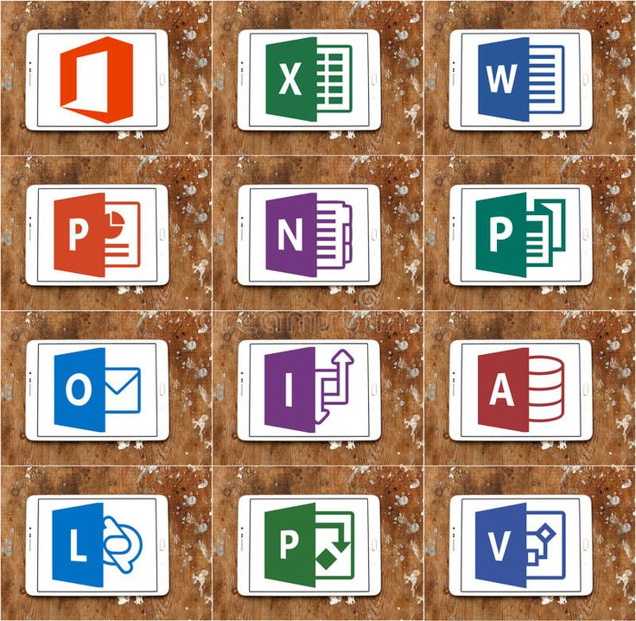
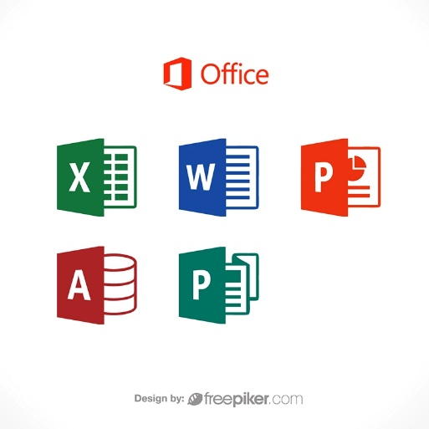

MS Office is the most widely used package in the world. It includes:
MS Office Application | Purpose
MS Word | Create documents (letters, reports, assignments)
MS Excel | Spreadsheets, calculations, data analysis
MS PowerPoint | Presentations, slideshows
MS Access | Databases
MS Outlook | Email and calendar
MS OneNote | Notes
MS Publisher | Brochures, newsletters

✔ Available on Windows & Mac
✔ Very powerful features
✔ Used in offices, universities, accounting, business, banking

2. LibreOffice — Free & Open-Source Alternative to MS Office
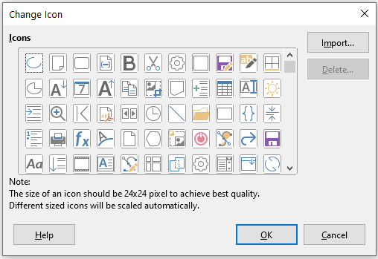
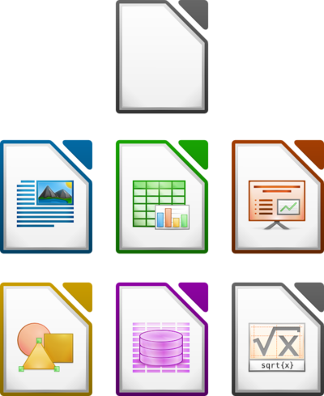

LibreOffice is a free office suite used worldwide.
It includes:
LibreOffice App | Equivalent to MS Office
Writer | MS Word
Calc | MS Excel
Impress | PowerPoint
Base | MS Access
Draw | Visio (diagramming)
Math | Equation editor
✔ Completely free
✔ Available for Windows, Linux, Mac
✔ Popular in schools, government, NGOs

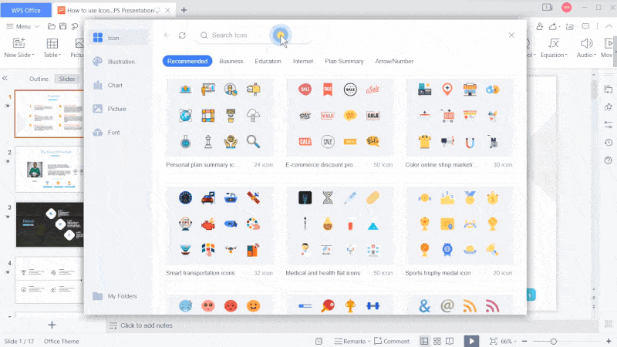
3. WPS Office

A lightweight, fast office package.
Includes:
- Writer
- Spreadsheets
- Presentation
- PDF tools
✔ Very similar design to MS Office
✔ Free version available
✔ Popular on mobile devices (Android/iOS)

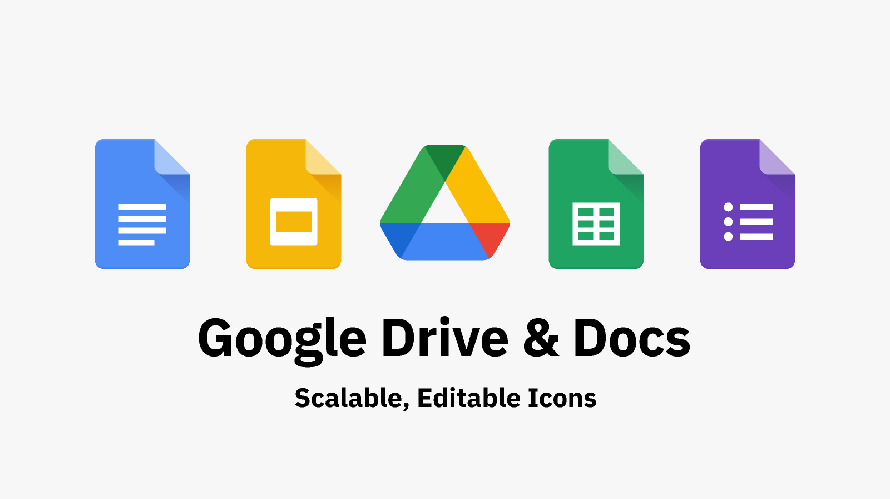
4. Google Workspace (Google Docs, Sheets, Slides)
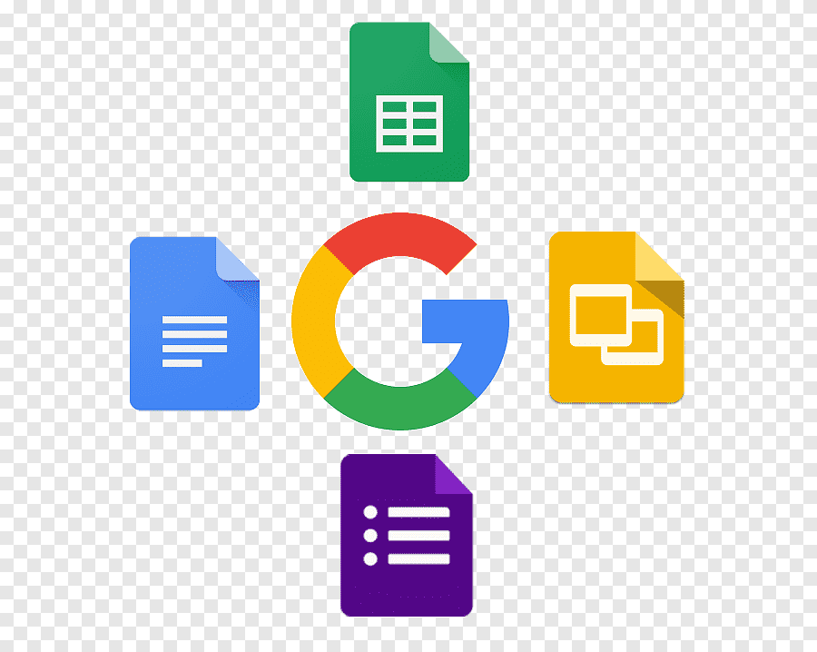

A cloud-based online office suite.
Includes:
- Google Docs
- Google Sheets
- Google Slides
- Google Forms
- Gmail
- Google Drive storage
✔ Works online in browser
✔ Real-time collaboration
✔ Auto-save in cloud
✔ Used by students and remote teams

⭐ 5. OnlyOffice
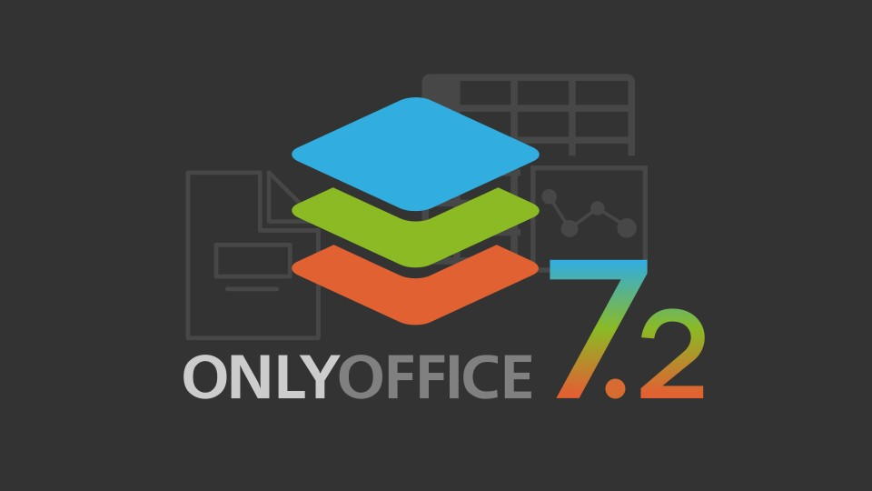
Another modern office suite similar to MS Office.
Includes:
- Document Editor
- Spreadsheet Editor
- Presentation Editor
✔ Used in organizations for team collaboration
✔ Works online & offline

6. Apple iWork (Mac/iPad Users)
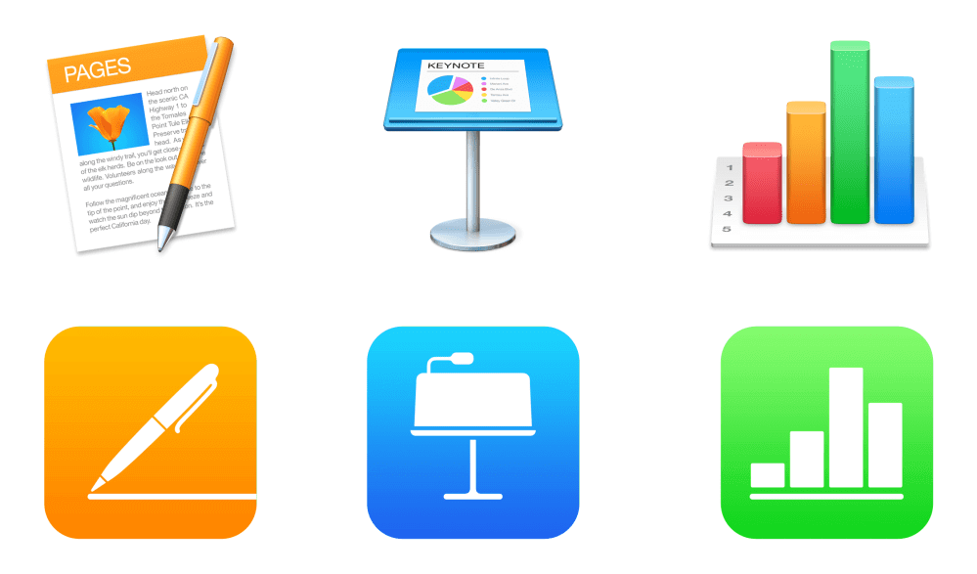
Includes:
- Pages (like Word)
- Numbers (like Excel)
- Keynote (like PowerPoint)
✔ Free for Apple users
✔ Very good for design and presentations

Office Package | Free? | Best For | Strength
MS Office | ❌ No | Companies, universities | Most powerful, widely used
LibreOffice | ✔ Free | Schools, NGOs, Linux | Open-source, offline
WPS Office | ✔ Free (basic) | Students, mobile users | Looks like MS Office
Google Workspace | ✔ Online | Collaboration, teams | Real-time teamwork
OnlyOffice | ✔ Free Community | Businesses | Modern, cloud + desktop
Apple iWork | ✔ Free | Apple users | Beautiful design

Importance of Excel in BBA

Excel is used in every field of business, and BBA students will rely on it in almost all courses.
✔ 1. Accounting  - Maintaining sales and purchase records  - Preparing cash books and financial statements  - Budgeting and cost calculations  - Profit–loss analysis | ✔ 2. Statistics  - Data entry and tabulation  - Statistical calculations (mean, median, frequency tables)  - Basic data visualization (charts, graphs)  - Trend analysis for business forecasting
✔ 3. HRM (Human Resource Management)  - Employee database  - Attendance sheets  - Salary sheets and allowances calculations  - Performance reports and metrics | ✔ 4. Finance  - Loan calculations  - ROI (Return on Investment)  - Interest calculations  - Portfolio comparisons  - Financial modeling (basic level for BBA)
✔ 5. Decision Making  - Comparing alternatives (e.g., suppliers, cost options)  - Scenario planning  - Summarizing data for management decisions  - Data-driven business strategies | Excel helps BBA students turn raw numbers into meaningful business decisions.

Working with Excel:
✅ What is Excel?
Excel is a spreadsheet software used to store, organize, calculate, and analyze data.
It allows you to create tables, perform mathematical formulas, make charts, and prepare business reports easily.
✅ Why Excel?
Excel is used because:
- ✔ It makes calculations fast and error-free
- ✔ It helps organize large amounts of data
- ✔ It creates charts and visual reports quickly
- ✔ It is used in Accounting, Finance, HR, Marketing, and Statistics
- ✔ It supports decision-making in business
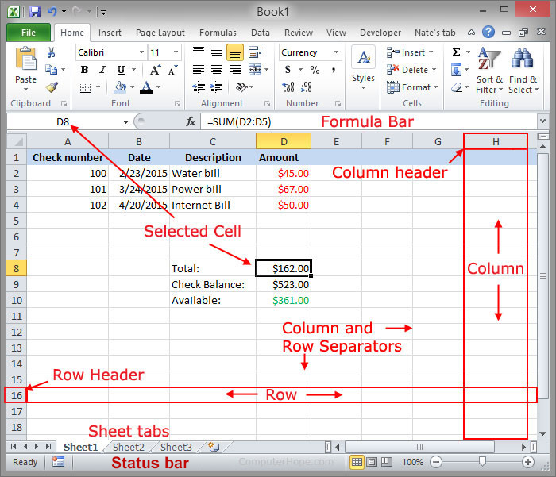
In short: Excel saves time, reduces mistakes, and turns data into useful information for business.

Scenario 1:

Scenario 2:

Scenario 3:

Scenario 4:

